

DR Failover and Testing Steps

for Call Credit optimus Azure project

Proprietary and Legal Notices

This document is the property of Inframon Limited; the contents herein are the intellectual property and copyright of Inframon Limited. Permitted disclosure of this document and its contents herein does not grant or construe any transfer or other rights in relation to Inframon Limited’s intellectual property. Clients may only use the contents of this document for their own internal business use, solely for supporting Inframon Limited’s intellectual property. No part of this document may be photocopied, reproduced, stored in a retrieval system or transmitted in any form or by any means whether, electronic, mechanical or otherwise without the prior written permission of Inframon Limited.

Contents

1 Executive Overview 5

1.1 About Inframon 5

2 Assumptions: 7

2.1 Pre-failover: 7

2.2 During DR 7

2.3 After failover 7

3 Out of scope: 8

4 DR Failover information 9

5 Performing Failover: 10

5.1 Single VM Failover: 11

5.2 Recovery Plan Failover – Multi-VM 13

6 Post VM failover steps 17

7 Testing services after failover. 18

Revision History

|  |  |  |  |
| --- | --- | --- | --- |
| Date | Changes | Version | Author |
| 06/06/2018 | Draft version | 0.1 | Karl Tremain |
| 07/06/2018 | Peer Reviewed | 1.0 | Ryan Stephens |
|  |  |  |  |

# Executive Overview

Call Credit has engaged with Inframon as part of their strategy to migrate compute workloads into the Azure cloud platform. Inframon has developed extensive experience with both Azure and the Microsoft product suite over many years of working on similar engagements and have been requested to provide an accelerated deployment for Call Credit to transition to the use of Azure. This document details the DR failover and test plan for this initial deployment based on the technical and operational criteria needed to deliver a highly available and flexible architecture from Microsoft Azure.

## About Inframon

* Founding principles based on technical ability
* Agile organisation – cloud specialists to large global enterprises
* Proven track record with migration to public and private clouds
* Strong and credible relationships with Microsoft and supporting Microsoft technology

Inframon is a Microsoft Cloud transformation specialist with expert knowledge and skills across the range of Microsoft hybrid based services including System Center 2016, Operations Management Suite and Azure.

As a Microsoft Gold Cloud and Microsoft Azure Gold Cloud Partner we have a proven track record of helping our customers to leverage Microsoft hybrid Cloud based services and applications to transform and modernise their operations and processes.

Now in its 11th year, Inframon was founded from an infrastructure perspective and bases its principles around recruiting great people and maintaining a strong technical and business focus. Both founders have strong technical backgrounds and the company has a history of supporting Microsoft on their enterprise accounts around Microsoft Systems Center.

Inframon has fast gained its reputation as the best in systems set-up with expertise at mastering the latest Microsoft innovations, gaining momentum and equipping customers to move from their legacy computing platforms and transforming them into cloud operating models.

A trusted agile partner helping our customers move to the cloud

Our customers want to move to cloud – a new world with a whole different set of complexities – and they want to partner with an expert who will help them manage that process. Inframon does exactly that, creating governance and control frameworks to manage and support the whole cloud journey, wrapping strategy and consultancy around the service together with our valued professionalism and expertise.

At Inframon we forge close relationships with our customers helping them with every step of the technology lifecycle – from vision and strategy, hardware, software and licensing, consulting through to support and managed services. Inframon prides itself on its ability to work with large enterprise organisations as well as SMEs to take them on their cloud transformation journey.

Inframon – Your Hybrid Cloud Management specialist

To meet the increasing complex needs of its customers Inframon has designed and developed the Hyper Cloud Platform, a technology that provides a highly automated and orchestrated control and governance framework, delivering self-service capability while maintaining control over all your cloud based assets.

# Assumptions:

## Pre-failover:

* Networking running and accessible in both regions (e.g. vnet/vpn/gateway/firewall/expressroute)
* “always on” vm’s running and accessible in both regions (e.g. domain controllers)
* ASR has already been configured on all VM’s in scope, and these are showing as healthy and protected in Azure Site recovery.
* Periodic “Test failover” scenarios have been performed at least every 6 months, and their results were considered successful.

## During DR

* access to Azure Portal is available by existing authenticate methods, and these methods are not affected incase of Azure region failure.

## After failover

* No failedover services to be left running and/or accessible in source region

# Out of scope:

The Callcredit “optimus” application is manged by callcredit’s IT team, therefore is out of scope for this failover and test plan. Please refer to internal Callcredit documentation for application specific testing.

# DR Failover information

When services failover to the DR site, known as “UK-B” (Currently located in the Azure region “UK West”) all incoming connections will be directed to this site using external load balancers and traffic managers.

These services are automatically made aware of the DR failover as they utilise health heartbeats to monitor services..

The virtual machines running these services will be moved over by manual business process when the need arises to move services into DR.

The Recovery time Objective (RTO) for a full DR failover is expected to be 4 hours or less, and this time starts once the decision to failover to DR has been made, and the first step in the DR failover process document is initiated.

Service health in DR will be confirmed by completing all test steps, and the RTO timer will be stopped upon successful completion of all tests.

The first step in failover is to initiate the process form the console, and wait for the virtual machines to boot up. Once booted, the traffic manager and load balancers will require up to 10 minutes to complete their changes to direct all traffic to the DR site. Additional time may be required to allow for internal DNS propagation delays.

Test steps can only be performed after waiting for the above 2 stages to finish.

# Performing Failover:

*** Please note that all screenshots are examples, and use dummy content, so your exact environment may be slightly different

Log into the Azure Portal (<http://portal.azure.com>)

Go into the recovery service vault for the DR region

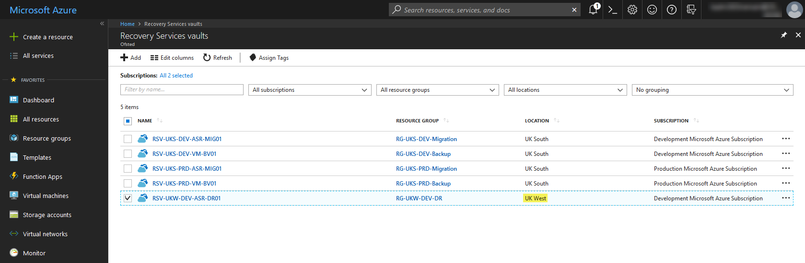

## Single VM Failover:

Go into the vault, choose replicated items and select the VM to be failed over

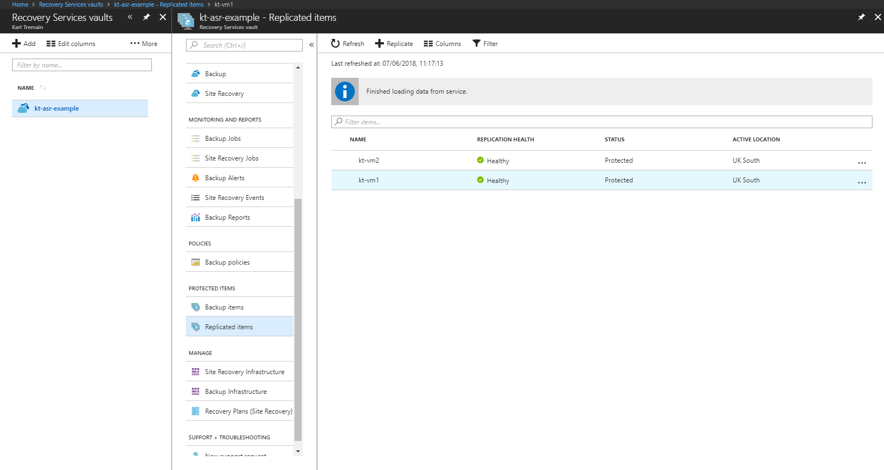

Choose failover

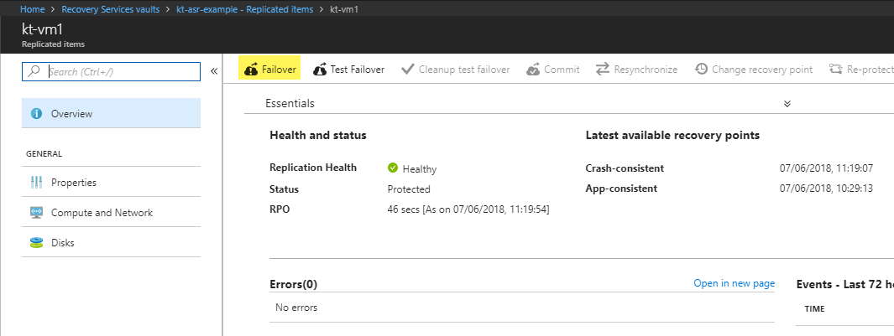

If this is a DR scenario when the source has gone offline, then you will have less choices around the recovery point and shutting down the source machine.

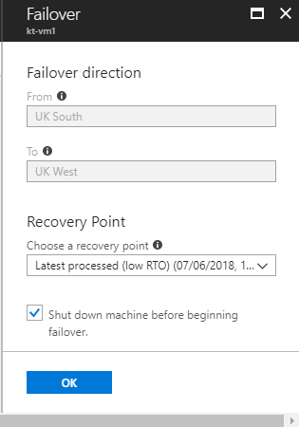

Choose OK, and the failover will commence.

This process can take up to 20 minutes to complete, after which the Virtual machine will be running in the Failover region, with a new IP address. Progress can be monitored if required via the “Site recovery jobs” section of the Vault.

## Recovery Plan Failover – Multi-VM

This section assumes that recovery plans had been pre-created before a failure occurs.

Select the required recovery plan; You may have multiple plans for each part of the service.

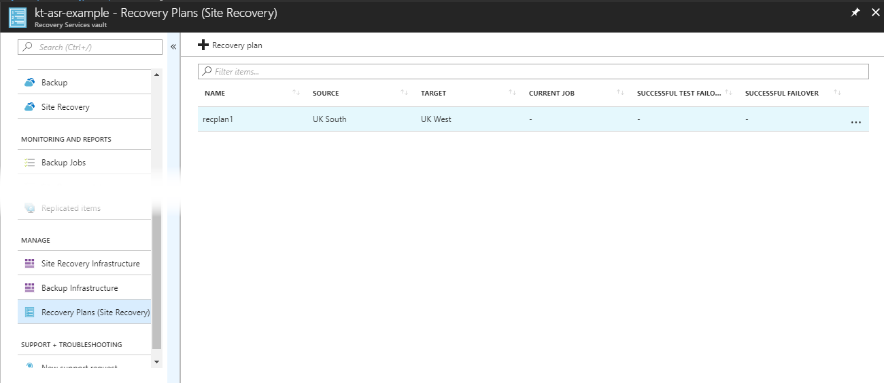

Select “More”, then select “Failover”. Again, if this is a DR scenario where the UK South region has gone offline, you may have less choices of “Recovery point” and “Shutdown machines”.

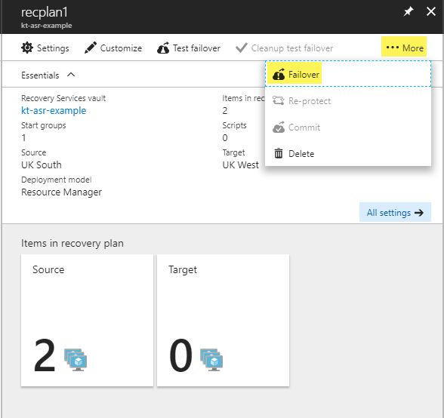

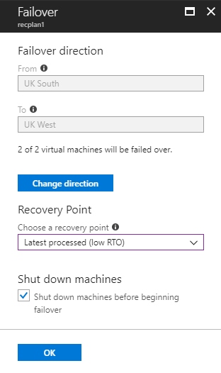

You will receive a notification which you can click on for further information.



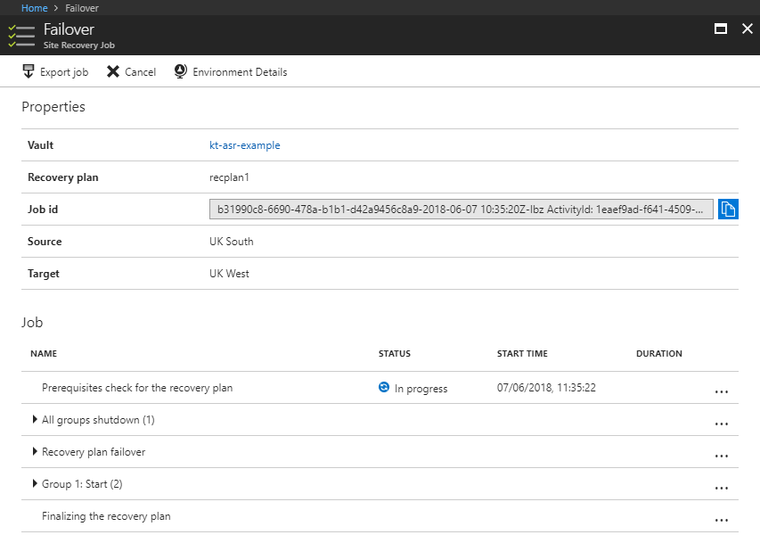

This will failover all VM’s in your recovery plan (2 in this example) and boot them up in the DR region (UKWest)

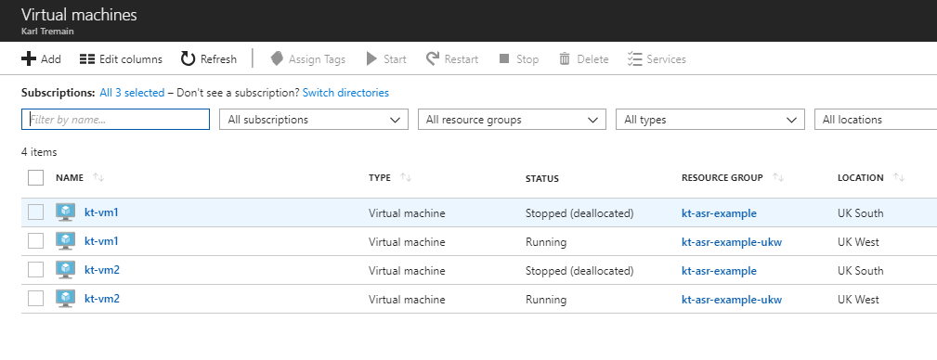

# Post VM failover steps

* Change Internal DNS record for SQL cluster
* Check traffic manager has correctly updated from the maintenance page to the running service

# Testing services after failover.

|  |  |  |
| --- | --- | --- |
| **Test** | Ensure that all virtual machines are booted to a logon prompt by use of the Azure Virtual machine Boot diagnostics | **Pass/Fail?** |
| **Expected result** | All virtual machines are at a logon prompt |  |
| **Reason for test** | This ensures that no machines have failed startup or crashed during the DR process. |

|  |  |  |
| --- | --- | --- |
| **Test** | Attempt to use remote desktop from a known permitted location to get onto each server in turn | **Pass/Fail?** |
| **Expected result** | RDP connection and logon works fine |  |
| **Reason for test** | This test that connectivity, DNS and authentication functions are working as expected |

|  |  |  |
| --- | --- | --- |
| **Test** | Check configuration of UKWest load balancers contain correct IP’s within backend pool | **Pass/Fail?** |
| **Expected result** | IP’s in pool match failed over VM’s |  |
| **Reason for test** | This tests that LB traffic can hit VM’s |

|  |  |  |
| --- | --- | --- |
| **Test** | Check configuration of application gateways in UK West region | **Pass/Fail?** |
| **Expected result** | Failed over VM’s are correctly listed in the backend pool |  |
| **Reason for test** | Ensure traffic flow is correct after failover |

|  |  |  |
| --- | --- | --- |
| **Test** | Check outbound flow of VM traffic in UK West region | **Pass/Fail?** |
| **Expected result** | Traffic flows through the preconfigured Paloalto firewall appliances |  |
| **Reason for test** | Check correct traffic flow through firewalls. |